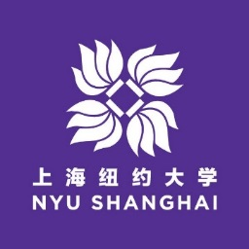

June 19, 2018

Dear Faculty,

Through NYU Shanghai's founding partnership with ECNU, Chancellors Chen and Yu have been involved in an initiative that allows a small select group of young outstanding ECNU faculty to interact with NYU Shanghai faculty and request permission to attend NYU Shanghai courses in their academic discipline or related field of interest. Last academic year, faculty from both NYU Shanghai and ECNU reported positive feedback from this academic mentoring experience.

For those ECNU faculty who have been invited to meet with NYU Shanghai faculty and attend NYU courses, we ask that you follow the guidelines as stipulated below:

- From the attached list of courses and course descriptions, please list in order of preference those courses you would be interested in attending;
- Please include a brief biographical statement about yourself – including name, academic interest; courses taught, etc;
- NYU Shanghai administration will then try to set up an opportunity for you to meet with relevant faculty and work out an arrangement for attending the class lecture(s);
- Note that there are limited spaces available in any given course and that it is not guaranteed that you will be able to attend your first or second choice course, but we will try our hardest to make this work out for you.
- Also be aware that some faculty have opened their entire class schedule to potential faculty auditors, while others may make just a small number of lectures available, and others may not be able to accept auditors this coming semester. We will keep you apprised of this.

Thank you very much for your interest in this mutual learning opportunity.

Sincerely,
Duane Voigt
NYU Shanghai University Registrar
1555 Century Avenue, Pudong District
Shanghai, China 200122

